CoronaRona Edition #2
Pull Cards
When you realize u did not mute camera & sound while using the bathroom during a Zoom call | Parenting Style During Quarantine  Sure, son Go for it | `  When you can’t get Botox for 18 months | Trying to homeschool 3 kids and work from home | The # of hours of Denver 2020 Prohibition
Your new Interns | Ozark Returns  Did you hear?  The new definition of excitement | The new form of Gossip  How do u know?  Saw it on Facebook | The Dinner Evolution | The happiest mammal on the planet
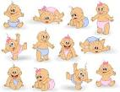  12/2020 – the birth of the next Baby Boomers | New definition of online shopping | The one mammal who has seen no change | Those who we appreciate more than ever ( & many more) – Thank you! | The hottest commodity
Your new Workout Group | 3, 4, 5…10  # of days between hair washing | The new Dating Scene | Better than….  almost anything | Boredom Buster  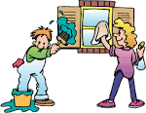
On Trend…Evening News | Outing for the day  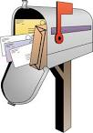 | For whom we have a new appreciation | The perfect time for new drivers | From this:  To this:
The new Spa Experience | The newest home addition  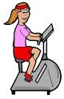 | Tik Tok  Where the tweens and teens are | Where tween and teen boys are if not on Tik Tok | Best time to dig all these out and give them a try
Playing in every house with young kids 24 x 7 | The theme song we can’t get out of our head due to repeat play | The only place to find privacy  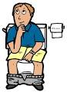 | Times we will hear “I’m Bored” | The season we will only see out the window in 2020

